**Special Paper for Computer Architecture**

2.

i. Convert following decimal numbers to the binary format. (Show the steps taken)

a. 70

b. 30

ii. Add above two numbers (70 + 30) using their binary values.

iii. What is the result of adding following two numbers?

0 + 0 = …

0 + 1 = …

1 + 0 = …

1 + 1 = … and to ...

iv.

|  |  |  |  |
| --- | --- | --- | --- |
| **A** | **B** | **SUM** | **CARY** |
| 0 | 0 | … | … |
| 1 | 0 | … | … |
| 0 | 1 | … | … |
| 1 | 1 | … | … |

v. Represent the sum and the carry out put using two input logic gate in the following block diagram.

A

B

Cary

A

B

SUM

vi. Using above logic gates, design a Half Adder logic circuit.

A

B

SUM

CARY

vii. Using above Half Adder circuit design the full adder logic circuit in the following block diagram.

A

B

SUM

CARY

Cin

1. Main hardware component of the computer is shown in the figure shown in the bellow.

3. 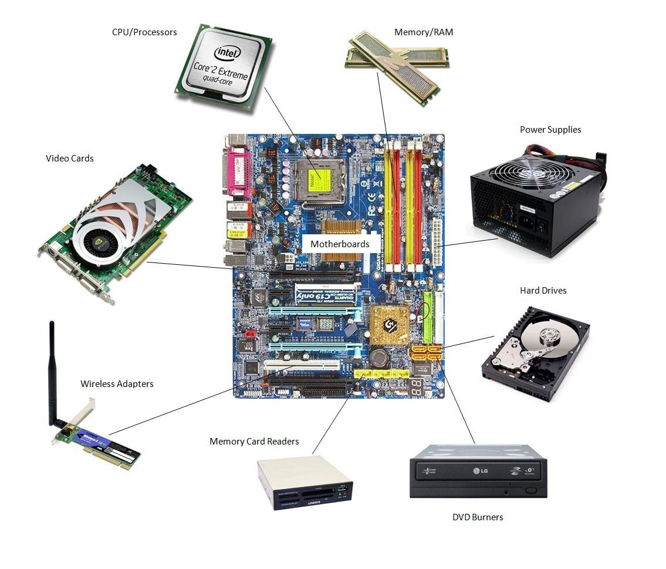

i. What is the main purpose of the Motherboard?

ii. When ever you are preparing a Power Point presentation to where is it temporary lorded or stored?

iii. Suddenly your desk top computer loosest the power supply, due to external power failure while you’re preparing the power point presentation. Computer was restarted as soon as it got the power.

a. It that Power Point Presentation is on the screen as it was appeared before the power failure occurred.

b. If you have saved the presentation 5 minutes before the power failure, what happened to the content added to the last five minutes period? State the reason for your answer.

c. Where it was stored the presentation just five (5) minutes before the power failure.

d. Why it was remain with the content added just before the power failure.

4. a. Name the followings busses shown in the picture (Marks 10)

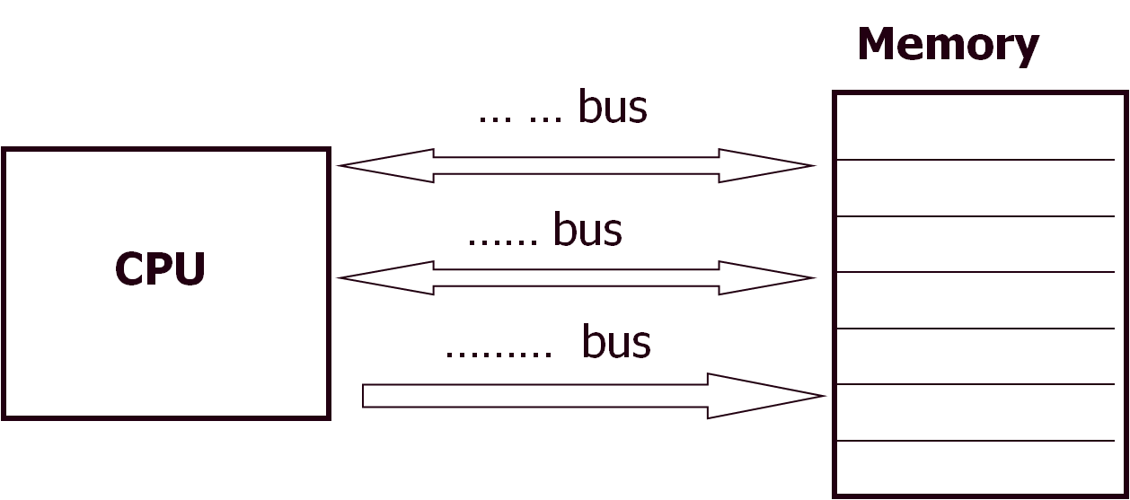

b. Explain the operation of each bus.

5. Prove the following shift operation perform the required operation using graphical aids.

The **Arithmetic Shift** instruction performs multiplication or division.

|  |  |  |  |  |  |  |  |
| --- | --- | --- | --- | --- | --- | --- | --- |
| 0 | 1 | 0 | 1 | 1 | 0 | 1 | 0 |

Use 8 bit binary value in the 8 bit register.

i. Convert binary number to the decimal number

ii. Multiply the binary number by 2 using binary shift operator

Hence obtain the decimal value for binary output.

iii. Divide the value by 2 using the binary shift operator.

Hence obtain the decimal value for binary output.

6. Put the following memory and storage devices in to a pyramid with a hierarchical order. (Marks 15)

Hard Drive, Magnetic Tape, USB Drives and SD Cards, Processor Cash, Processor Registry, RAM.

Following featured to be consider

Cost, Size, Speed, Data Storage Capability with Power On/OFF Conditions